**Assignment - Roll no. 42**

1. What is the difference between truncate, delete, drop?

Delete is a DML(Data Manipulation Language) Command

Delete Command is used to delete either one or more records from the table

We can use Where clause to delete a specific record.

Delete Command performs slower than drop and delete as it iterates through each record to delete a specific record.

Syntax: DELETE FROM table_name WHERE condition;

Drop is a DDL(Data Drfination Langauge) Command.

Using Drop we can drop the whole table from the database

Drop command delete the table from the database after deleting rows hence, Drop Command is not as faster as Truncate command but is faster than the delete command

Syntax: DROP TABLE table_name;

Truncate is a DDL(Data Definition Language Command)

As where clause is not used in Truncate, we cannot delete a specific record, Its deletes every record in the table

Truncate command is faster than Delete and Drop command as it deletes all records in one go.

Syntax: TRUNCATE TABLE table_name;

2. What are alias in MySQL?

* It is used to rename a table or a column temporarily by giving another name known as Alias.
* An alias only exists for the duration of that query.
* Aliases are often used to make column names more readable.
* An alias is created with the AS keyword.

3. How do you display even rows of the any table?

select t.r, t.employee_id, t.first_name from (

select *, row_number() over(order by employee_id) as r from employees) t

where t.r % 2 =0;

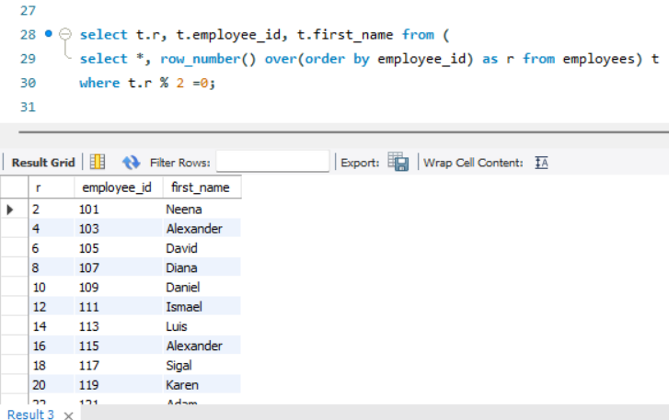

4. How can you remove duplicates from a table(distinct and other way)

1. Using distinct

select distinct first_name from employees;

1. Using group by

SELECT first_name, COUNT(*) AS counts FROM employees

GROUP BY first_name HAVING counts > 1;

5. How you can find 5th max salary?(Do it by all 3 ways)

1. Using limit

select first_name, salary from employees order by salary desc limit 4,1;

SELECT * FROM employees ORDER BY salary DESC LIMIT 1 OFFSET 4;

1. Using dense_rank()

select * from (select dense_rank() over(order by salary desc) as ranks, first_name,salary from employees) a where ranks=5;

-CTE

with temp as (

select dense_rank() over(order by salary desc) as ranks, first_name,salary from employees

)

select * from temp where ranks=5;

1. Using count()

SELECT first_name, salary FROM employees AS emp1

WHERE 5-1 = (SELECT COUNT(DISTINCT salary) FROM employees AS emp2

WHERE emp2.salary > emp1.salary);